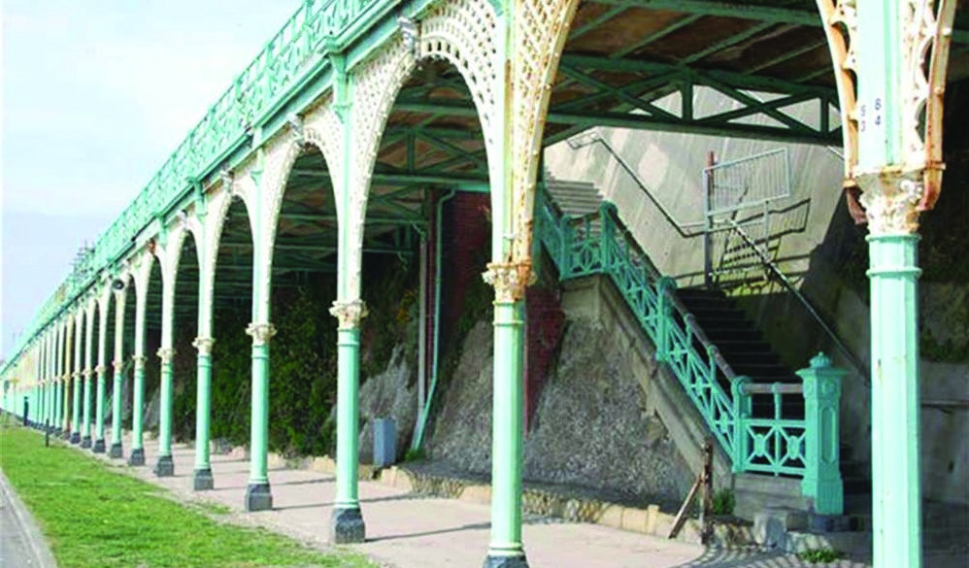
SUMMER INTO AUTUMN NEWSLETTER
KEMP
TOWN

SOCIETY
Last chance to save the Terraces!

On 26th July a crowdfunding scheme was launched through Spacehive to save our beloved Madeira Terraces, which Brighton and Hove Council does not have the money to repair. If this does not work, they will simply corrode away, and one of Brighton’s loveliest features (together with the much-loved Max Miller walk along the top) will disappear. The Terraces need you!
Jill Sewell and Vaughan Rees from the KTS committee were at the launch. Jill reports:
The launch began with talks by two people who had used Spacehive to promote their local projects. Wells Street Market in London was now thriving, having raised £883,000. Camden Town Unlimited were using Spacehive for a green walkway on a raised disused railway. They had both obviously been very active in promoting their respective appeals. They found Spacehive an effective way to raise money, though they stressed that project leaders were vital to keep it going, that they had to make good use of community databases, and they had to keep on asking. I was unclear who was to lead the effort for the Terraces. They supported the view that if sufficient local funding is raised in this way, quasi-government bodies and charities, seeing the local enthusiasm, would make substantial grants to help. The Council has already pledged £100,000.
If the target funds are raised, all pledges become nonreturnable and are spent on the project. If the target is not reached, the pledged sums are returned. Spacehive receives 5% of the amount raised as their fee.
There are 150 arches in Madeira Drive and the total required is about £450 million. The Spacehive site is intended to provide the funds for the first 3 arches and the Council is confident the rest will follow if it is successful. The overall project is to restore the whole run of arches from the pier to the Shelter Hall (Concord Bar under the lift). The commercial use of the restored arches is not clear, and will vary from small units, similar to the retail spaces on the seafront under Kings Road, to occasional ‘pop-ups’.
The website is now up and runs until 23rd November. To make a pledge, and learn more, go to www.savemadeiraterrace.org.

Other developments “down our end”
Jill reports from an earlier meeting on “East of the Pier”:
“The infernal Conference Centre mooted for Black Rock was rather glossed over, although I was assured that (i) everyone was aware of the cliff-height restriction (ii) funding for this was not yet available and (iii) transport problems to and from had to be solved for it to be viable. The building is currently envisaged as multi-storey, circular and below cliff height. Beyond this, it was not discussed.
Work on the open-air swimming pool is likely to start soon; it will be close to the Yellow Wave café with access from the Shelter Hall (Concorde). We discussed overhauling the lift to improve access between the A259 and Madeira Drive, which would be useful for access to the swimming pool. Sadly, the Council were not interested in cleaning up Dukes Mound (with the possible exception of having pop-up lighting, whatever that is!) and appeared unaware “and possibly incredulous” that the lower slopes fall within the Kemp Town Conservation Area.
“Transport on Madeira Drive remains a problem. We talked about a frequent-stop, possibly electric, bus and making more use of the Volks railway, possibly by burying the live electric rail and removing the fences on either side of the rails to increase access to the beach. The advent of Boris bikes (a rank is planned for Madeira Drive) will provide another option.
“It was very evident that without seed capital (and no major source other than crowdfunding was anticipated) nothing much would happen, with the possible exception of the swimming pool.”
c/o 4 Sussex Square Brighton BN2 1FJ
Company limited by Guarantee No. 7734051 Registered Charity No. 1146155
continued on page 2
continued from page 1
Bins: non-passive resistance!
In June two green wheelie-bins, which were soon overflowing in the hot weather, were outrageously parked on either side of the south-western gates to the Gardens. (Bear in mind that no decision has yet been made about the siting of bins on the Estate – or, if it has, we have yet to hear.) Huge thanks to the residents of 13 Lewes Crescent, who created such a fuss that the council sent a white van to remove the offending/offensive bins, and they have not reappeared.

The Marina…
Sadly, we lost our appeal to the High Court in June. According to Robert Powell, who led the legal effort, our lawyer thought there were some grounds to appeal again, but we have reached the point where no more funds are available.
Many of us have noticed, however, that work on the dreaded tower appears to have paused. Robert, having visited the site, reports that the coffer dam appears to be complete, with a system for keeping water pressure equal on both sides of the Western Breakwater; but that Midgard’s presence now seems reduced to two huts. Possibly wobbles about the economic climate, or post-Grenfell nerves?
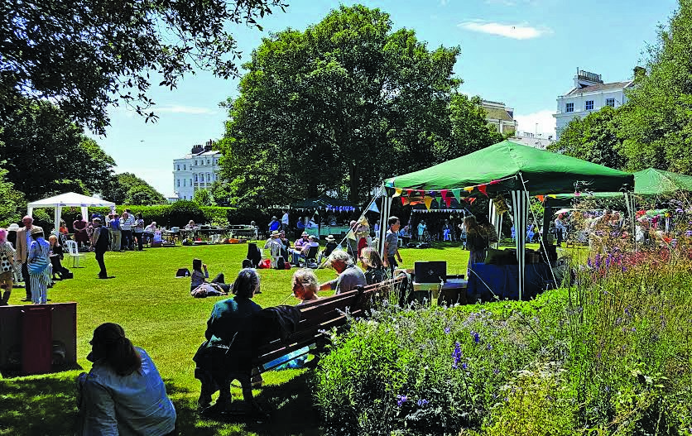
honours should also go to my Economist friend Ush Esling, who made the lovely new banners for the gate and the stalls. My thanks to all stallholders and helpers, to the put-uppers and take-downers, and not least to Johnny Muxlow’s Vintage Hot Five (this year with added Sousaphone!) whose music, as one partygoer said, “really is the sound of summer”.
Garden Party 2017
Sue’s scarves: the inside story
Although (as usual) we had hardly dared look at the advance
weather forecasts, on July 1st the sun shone, heralding the start of
the heatwave; and a merry crowd descended on the North Garden
to drink, feast, listen to the band and bask in unaccustomed
warmth. Thank you to all who came and made the day!
There were two new stalls this year: Jennie Thorne’s bric à
brac, with a marvellous and very competitively priced display, and
Glenys Horton’s vintage postcard stall, which proved fascinating
to old and new Kemp Towners alike. I very much hope that both
will be back next year. Rupert Bagilhole and Cathy Moss had
also worked tirelessly first to rescue and then to transform the
raffle, with (among many other prizes) several donations from
local businesses, whose support of the Party we’re obviously
keen to encourage. And while on that subject, a hearty thanks to
wonderful Marmalade, for so generously donating for the second
year running a delicious load of cakes to the Cake Stall.
This year’s theme was stripes, which produced a rich crop of
old school blazers (and, as Simon Smith remarked, at least one to
which the wearer was not entitled). And although, because of the
organiser’s incompetence, there was no prize for best outfit this
year (there will be next, I promise!), there were some splendid
monochromatic and multicoloured confections. Needlewoman’s
Ann Wroe
If anyone has good ideas for next year, do let me know. I have a dream of a craft stall to advertise all our local potters, painters, embroiderers, photographers, etc; how about that?
We should not hold our breath, but Brexit may yet achieve something that the legal process denied us.

Sue Dunlea’s scarf stall is an especially colourful part of the Garden Party. Here’s how it all started:
“When on holiday in the Himalayas in Northern India, I was amazed to see the fantastic range of local textiles. Staying in a village in the Kullu valley, I was astounded to see the local women with a baby strapped on their backs, herding their cows and at the same time knitting the most intricately patterned woollen socks. These socks provide the women of the region with one of their sources of independent income.
“The women also showed me how they hand-spun the local sheeps’ wool for knitting and weaving. On their verandahs they weave large colourful woollen shawls called patou. These are worn as traditional costumes.
“I started to collect and bring back socks and shawls bought directly from individual women or from the women’s co-operative in the main town of Manali.
“Because silk is not produced in the mountains, I buy silk wraps
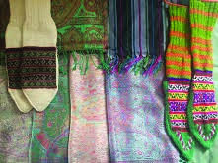
and scarves from various markets in Delhi to bring back to the UK. These vary from classic paisley to innovative modern design. The exceptional quality of these silk scarves is reflected in the rich colours and soft feel. I enjoy both displaying and selling them at various stalls in Brighton.”

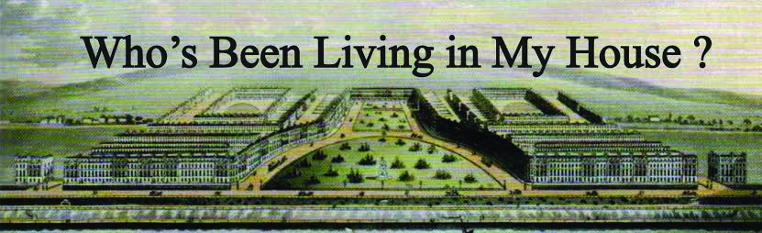

Plasterwork
Many of the houses on the Estate contain very ornate and beautiful plasterwork.
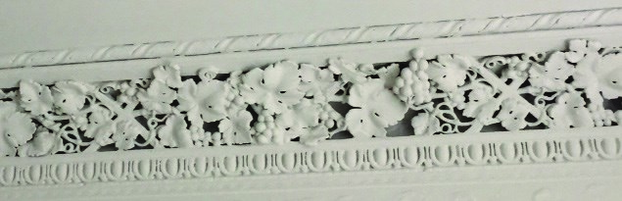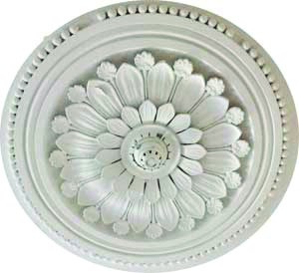
10
Lewes Crescent
1
Sussex Square
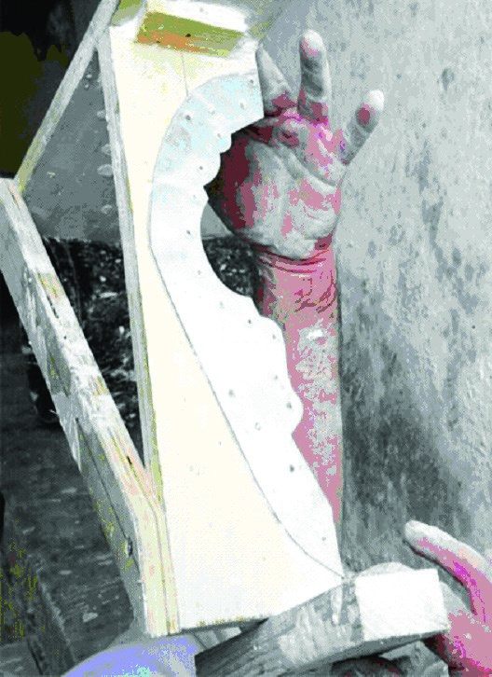
Cornices serve a practical purpose as an architectural device to cover structural joints between the walls and ceiling. Ceiling centres, friezes, corbels, panels, dado rails and skirtings made with plaster mouldings became an art form in early Victorian times.
Cornices were put up in situ using a ‘running mould’ and plaster ‘enrichments’ (individual decorations) were added to enhance the overall effect. Lengths of ornament, or ‘runs’ are made by pushing a metal form cut to the profile of the moulding required through wet lime plaster.
Original early Victorian work can be identified by the depth of ornamentation. This was more complicated to achieve and often required single cast pieces to be installed one at a time. A simple example of this can be seen on the exterior of many houses on the Estate – the little ‘champagne corks’ on the porches are, to this day, cast and applied separately during restoration.
To read more on this subject go www.kemptownestatehistories. com click on The Estate and you will find a number of articles concerning life on the Estate listed on the right hand side of the page – including ‘Plasterwork’
If you have a particularly special example of plasterwork in your house, please send a photograph to vanessaminns.no28@gmail. com, and this can be added to your House History.

ANNOUNCEMENTS

EVENTS FORTHCOMING
Save the date!
We will be holding another KTS Quiz Night at St George’s church on Friday 1st December.
Start assembling your teams of six, although we will happily find you a team to join if you are coming solo. Quizmaster Robert Snell has kindly agreed to set the questions again, although he is aiming at a shorter quiz this year. £10.00 p.p. Light supper included. Cash bar.
The Friends of St George’s Church are delighted that the church’s fine clock is currently being repaired with money raised by nine events held since last September. Thank you for your splendid support. They warmly invite you to join them again this autumn.
Saturday 9th September: Professor Monique Simmonds
will speak on “Murder, Fraud, Health: the Uses of Kew’s Collections”. She has astonishing stories to tell of how Kew’s deep understanding of plant science has contributed to modern life – including solving mysteries.

NEWS FROM THE SECRET GARDEN
From 8th-10th September the Secret Garden will be opening again as part of Heritage Open Door. Gavin Henderson and the Trustees hope you will come and see how this magical place is progressing!
The Trustees will be on hand to talk about future plans and exhibitions, and there will be handouts on the plants and plantings. Visitors are invited to relax there, and artists are welcome to draw or paint.
Luxury teas and autumn produce will be available.
During 2017 the trustees have been masterminding work on the garden. They have commissioned Landivar Architects to upgrade all the facilities, so that the Garden will be operational for visitors and available for special hire next year. Their experienced plantsman has been cultivating the area through all the seasons, shaping mature shrubs and adding many new species to the planting scheme.
When the facilities are completed, the Trustees plan to stage two exhibitions annually: one in May, featuring a leading sculptor, and one in the summer to display the finest emerging new talents.
For those who haven’t yet found it, the entrance to the Garden is on Bristol Gardens, near the corner with Bristol Place.
The opening times in September will be Friday 8th, 12-5pm; Saturday 9th and Sunday 10th, 10am-5pm. Don’t miss it!
Saturday 21st October: John McKean, architect and historian, will give an illustrated talk on the great Renaissance painter, Piero della Francesca: entitled “Piero’s Eyes”.
Thursday 23rd November: Suzanne Hinton, linguist and
local historian, is the translator of a fascinating record of Regency life: “Sketches of Brighton 1827 by a French Nobleman”. Suzanne will describe what she has learned from this vivid account, and will have copies for sale.
All events are held at St George’s Church, Brighton
BN2 1ED. Doors open at 7.00pm. Talks start at 7.30pm. Tickets are £14, and include a light supper or cheese platter and a glass of wine. Gallery tickets £7 for talk only. Cash bar.
Reserve your tickets at friendsofstgeorgeschurch@ gmail.com, or buy online at Eventbrite.co.uk
Congratulations!
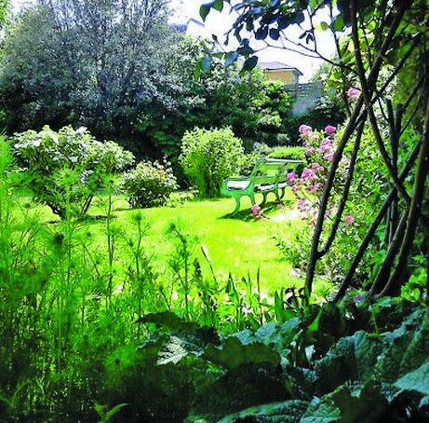
The refurbishment and fit-out of 14 Sussex Square has won a 2016 Sussex Heritage Trust Award for a small-scale residential development. The awards (sponsored by the Rausing Family Trust), have been going for 19 years, and recognise and reward the highest-quality conservation, restoration and good design across Sussex. The award is shared by DK Architects and the owners, Craig Jones and Adam Mason. Congratulations to all of you.
Photo: Lianne Jarrett

Please send all copy and ideas for the next newsletter to annwroe@economist.com by early December.
Thankyou!

